小学英语六年级下册期中测试题

姓名 班级 评分：______________
- 听音，选择。（10分）
（ ）1. A. 15kg B. 15cm C.50kg
（ ）2. A. clean B. climb C. climbed
（ ）3. A. take B. tail C. took
（ ）4. A. play football B. play the piano C. go by plane
（ ）5. A. wash B. watch C. wear
（ ）6. A. buy B. bike C. nine
（ ）7. A. ski B. skate C. snake
（ ）8. A. present B. parents C. pear
（ ）9. A. I’m fine. B. I’m nine. C. I’m five.
（ ）10. A. He’s sad. B. He’s sick. C. She’s thin.
- 听录音，判断对错。（10分）


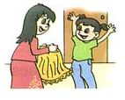
1. 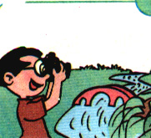 2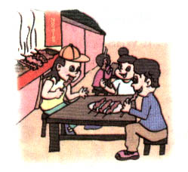3 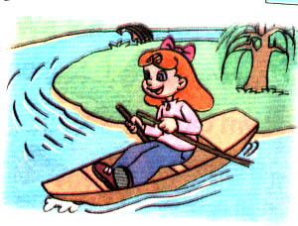. 4.  5. 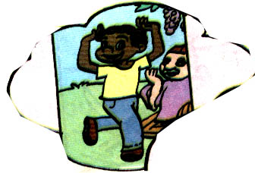
（ ） （ ） （ ） （ ） （ ）
6. Yesterday was Wednesday. ( )
7. Mike rowed a boat last Sunday. ( )
8. We went to visit our grandparents last night. ( )
9. I went skating last year. ( )
10. Tom was sick yesterday. ( )
- 听问题，选答句。（10分）
（ ）1. A: I went to the bookstore. B: I bought some books.
C: I bought some shoes.
（ ）2. A: She sees elephants. B: She saw elephants.
C: She’s going to see elephants.
（ ）3. A: Yes, I did. B: Yes, I do. C: Yes, I am.
（ ）4. A: No, she doesn’t. B: No, she didn’t. C: No, I didn’t.
（ ）5. A: She’s angry. B: She’s taller. C: She’s gong to the hospital.
- 听录音，填词。（10分）
1. A: did they go there?
B: They there by .
2. We many at the zoo.
3. A: Did she good food in Xinjiang?
B: Yes, and she some there.
4. I on my holiday.
- 听录音，判断句子对错。（10分）
（ ）1. Tom went to see animals last weekend.
（ ）2. Tom likes animals.
（ ）3. Tom’s mom went shopping.
（ ）4. Tom’s dad read some magazines.
（ ）5. Tom’s family had a good time last weekend.
笔试部分
- 补全对话。（把编号写在横线上）（10分）
Ａ. What did you do yesterday? Ｂ. How did you go there?
Ｃ. What day is today? Ｄ. What did you do there?
Ｅ. What day was yesterday? Ｆ. Did you play computer game with your cousin? Ｇ. Yes, I did.
A: ?
B: It was Saturday.
A: ?
B: I went to visit my cousin.
A: ?
B: I went by bike.
A: ?
B: I played computer game with my cousin.
A: Did you eat good food in your cousin’s home?
B: . It was delicious.
- 阅读理解。（10分）
On National Day, we had a long holiday. We had seven days. I went to Hainan with my parents. My grandparents lived in a beautiful village in Hainan. We visited them. We went to see the blue sea every day. We swam in it. We went fishing. My grandma cooked good food for us every day. The seafood is tasty. I like it . We took many pictures. I was excited.
( ) 1. I went to Hainan with my .
A: father and mother B: grandparents
( ) 2. There are days on National Day. A: a week B: seven
( ) 3. I was on National Day. A: very happy B: tired
( ) 4. I can in Hainan. A: went fishing B: swim and go fishing
( )5. We ate good food . A: on National Day B: every day
- 短文选词填空。（10分）
(well, China, dinner, singer, comes,
pictures, next, swimming, family, writer)
Nick is my new friend. He _________ from Japan, but he lives in _________. He has a happy ___________. His father is a ___________.
He often writes the TV show. His mother is a ____________. She sings
____________. She likes cooking___________. Nick likes drawing __________ and __________. I’m going to visit him _________ Saturday.
根据答句问问题。（10分）
1. A:
B: We’re going to the zoo this Sunday.
2. A:
B: I ate dinner at 7:00 last night.
3. A:
B: John went to school by bus.
4. A:
B: Mary bought some story- books in the bookstore.
5. A:
B: No, I went ice-skating last week .
- 看图作文。（10分）
根据图片，请用英语描述一下Mike去年到北京做了哪些事情？心情怎样?（不少于五句话）
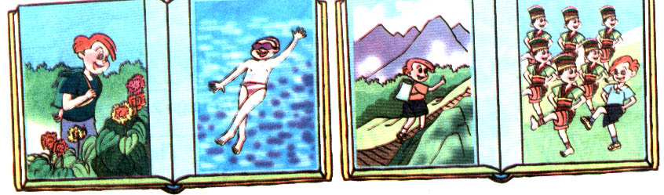

六年级期中听力材料及参考答案

一. 1. B: 15cm 2. A: clean
3. C: take 4. B: play the piano
5. C: wear 6. A: buy
7. B: skate 8. A: present
9. A: I’m fine. 10. B: He’s sick.
二. 1. I like taking pictures. (√)
2. Tim went hiking last weekend. (×)
3. Amy can row a boat. (√)
4. What do you usually do after school? I often read books. (√)
5. What did you do at the party? We sang and danced. (√)
6. Today is Thursday. (√)
7. Where did you go last Sunday? I went to a park. What did you do there? I flew kites. (×)
8. Did you watch TV last night? No, I visited grandparents with my parents. (√)
9. I went to Beijing last winter and I went skiing in Beijing ,too. (×)
10. How do you feel, Tom? You look tired. Yes, I had a fever yesterday. (√)
三. 1. What did you do in the bookstore? (B)
2. What does she do at the zoo?(A)
3. Are you going to be an engineer? (C)
4. Did your mother watch cartoons yesterday evening? (B)
5. How does Amy feel? (A)
四. 1. How got boat 2. saw elephants
3. eat bought presents 4. learned Chinese
五. Hello, I’m Tom. My family had a good time last weekend. Let me tell you. I went to the nature park to see animals. I took many pictures for them. The animals were so cute. My mother did housework and cooked dinner at home. My father read some newspapers. In the evening, we ate dinner ad watched TV together. That was fun. What about you? What did you do last weekend?
1. √ 2. √ 3. × 4. × 5. √
六. Ｅ. Ａ. Ｂ. Ｄ. Ｇ
七. 1. A 2. B 3. A 4. B 5. A
八. 1. comes 2. China 3. family 4. writer
5. singer 6. well 7. dinner 8. pictures 9. swimming 10. next
九. 1. Where are you going this Sunday/ What did you do this Sunday?
2. When did you eat dinner last night? 3. How did John go to school?
4. What did Mary buy in the bookstore?
5. Did you go hiking/…. Last week?
十. 略。

