pep人教版六年级英语下册复习题各单元
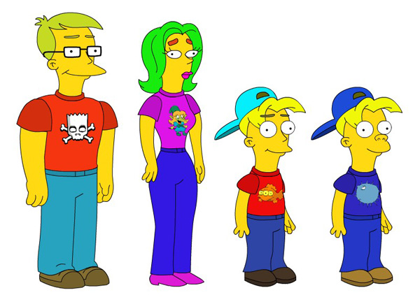
比较各题的两幅图片和提示，填上合适的单词，使句子完整。
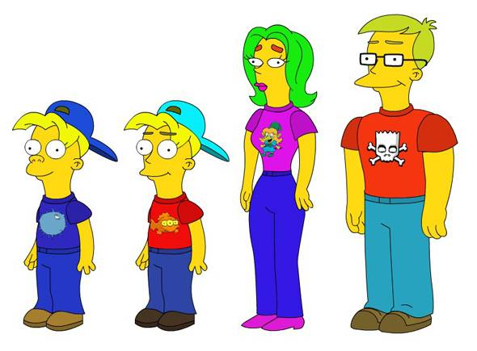
- I am ___________ than Tom.
Tom
I
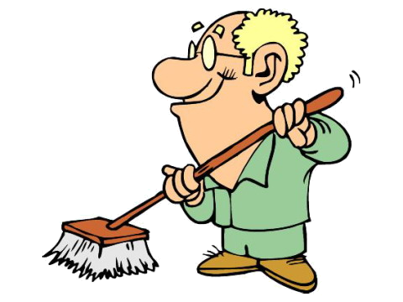
Tom is ___________ than me.
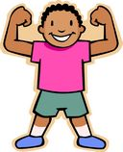
- My grandpa is ___________ than your brother.
Your brother is __________ than my grandpa.
20岁
70岁
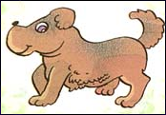
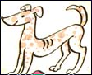
- This dog is ____________ than that dog.
That dog is ____________ than this dog.
50kg
20kg
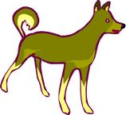
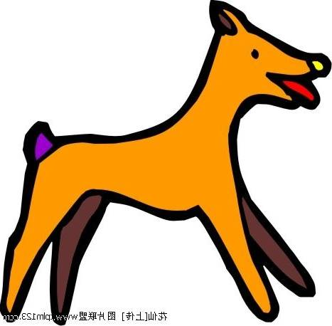
- My dog is ____________ than your dog.
Your dog is ___________ than my dog.
100cm
50cm
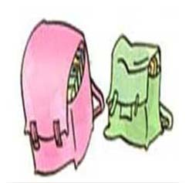
- Mike’s bag is ____________ than Sarah’s bag.
Sarah’s bag
Sarah’s bag is ___________ than Mike’s bag.
Mike’s bag
二、看答句写问句。
1. A: ____________________________________?
B: I’m 150cm tall.
2. A:_______________________________________?
B: Lucy is 15 years old.
3. A: ______________________________________?
B: No, my father is 60 kg.
4. A: _____________________________________?
B: Tom is taller than you .
5. A: ________________________________________?
B: I wear size 33.
6. A: ___________________ ___________________?
B: No, my legs are 74cm long.
7. A: ___________________________________?
B: Amy’s hair is 20cm long.
8. A: _____________________________________?
B: The tree is 36 meters tall.
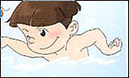
9. A: _____________________________________?
B: He’s swimming now.
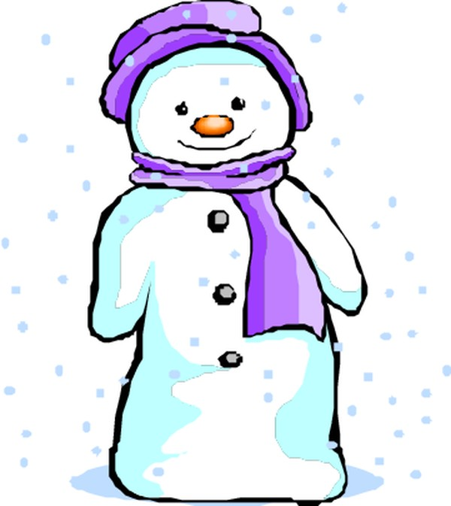
10. A: ___________________________________?
B: I like winter best.
四．根据上下文，补充句子。
A: Hi! _______________________________________?
B: I’m 55kg . ____________________________________?
A: I’m 50kg. ____________________________________?
B: Yes, I’m 5kg heavier than you. _______________________?
A : My legs are 70cm long. Your legs are 76cm.
B: Yes, __________________________________.
五．选词补充短文。
(older, younger, are, is, playing, old, going, climbing, reading, listening, one, two, three, longer, shorter)
John is 12. He has three friends. They are Sarah, Amy and Mike. Sarah is 12 years _______. She has long hair. Sarah likes ______ the piano very much. Amy is 13. She is ______ year ______ than John. Her hair is not long, it is ______ than Sarah’s hair. Amy likes ________ books. Mike is 10. He is____ years ______than John. Mike and John like ____________mountains. They ______ good friends.
七、小练笔，根据给出的图表，用比较级写几句话，不少于五句话。
Name | Age | Height | Weight | Hobby
Chen Jie | 11 | 150cm | 42kg | 游泳
Sarah | 13 | 162cm | 45kg | 跳水
______________________________________________________________________________________________________________________

六年级下册第二单元练习题 Name:______________
- 根据各题的图片，填上合适的单词，使句子完整。
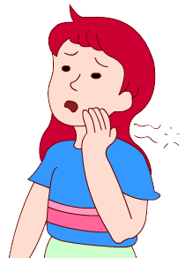
- A: ________ the matter with you?

B : I a ______________.
2) A: _________ does Tom feel?
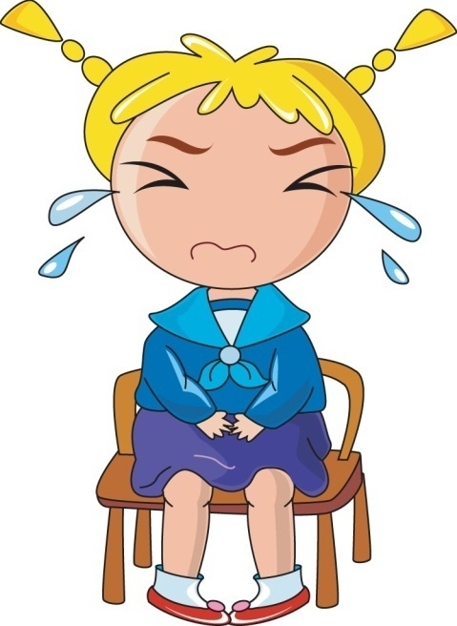
B: He is very _____________.
3) A: How are you, Lucy?

You _______ so ________.
4) Look, Zhang Peng _________ _________.
5) A: What’s the ________ Lily?
B: She a fever. Her leg ___________.
二、看答句写问句。
1. A:___________________________________?
B: I feel sick. I’m sad.
2. A:___________________________________?
B: I’m 14 years old. I’m older than you.
3. A:____________________________________?
B: Zhang Peng is 160cm.
4. A:______________________________________?
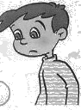
B: Tom is tired today. He went to bed late yesterday.
5. A:______________________________________?
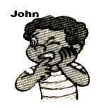
B: Miss Li is a music teacher. She’s pretty.
6. A:_______________________________________?
B: John has a toothache.
7. A: ? B: My brother is 62 kg.
8. A: ？ B: My throat is sore.
三、根据上下文，补充句子。
A: Hi, Lily. __________________________________?
B: It’s sunny today.
A: __________________________________?
B: I feel well. __________________________?
A: I am sad.
B: ______________________________________?
A: Because my parents will go to Hong Kong, but I can’t go.
B: ______________________________________?
A: They’re going there by plane.
B: ______________________________________?
A: They are going to go shopping in Hong Kong.
B: I’m sorry to hear that.
四、根据课文内容填空
Some people feel in winter. Many people the flu. Do you a sore throat? your nose hurt? you have a headache? If you have a , you might have the flu.
Don’t worry. If you sick, the doctor. some medicine and hot drinks. in bed a few days. You will feel soon.
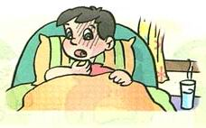
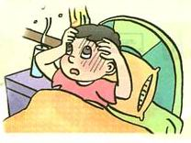
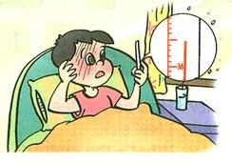
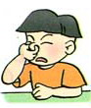
五、看图作文: 请用英语描述一下如果你得了流感有何症状，应该怎么办?(不少于五句话)

六、看中文写英文。
1.牙疼:______________ 2.疼痛: 3.感冒:____________
4.高兴的 5.生气的 6.悲伤的
7.兴奋的 8.疲劳的 9.无聊的
10.你怎么啦？我的腿疼。
11. Amy感觉怎样？她觉得很累。

六年级下册第三单元练习题 Name:______________
一、根据各题的图片，填上合适的单词，使句子完整。
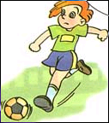
1. A: What _____ you do last Saturday?
B: I _________ football with Mike.
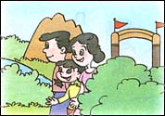
2. My family ______ _______ a park yesterday.
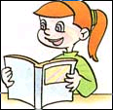
3. A: ________Sarah wash clothes yesterday?
B: No, she ________. She a book.
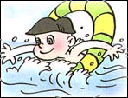
4. A: Did you ______ swimming yesterday afternoon?
B: Yes, I ________. I swimming yesterday.
5. I often _______ football on the weekend.
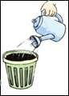
6. I am going to _________ the flowers after school.
7. A: Your room is clean. B: Thanks. I ________ it this morning.
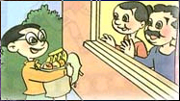
8. A: What is your father doing? B: He is __________ an e-mail.
9. I _______ my grandparents last weekend. We had a good time.
二、看答句写问句。
1. A: ___________________________________?
B: I’m going to climb mountains tomorrow.
2. A: __________________________? B: I played football yesterday.
3. A: __________________________? B: I often go shopping on Sunday.
4. A: _________________________? B: I’m reading a book now.
5. A: _________________________?
B: I can cook the meals at home.
6. A: ?
B: Yes, I went fishing last weekend.
7. A: _______________________________________?
B: Yes, my parents go to work by bus.
8. A: _______________________________________?
B: No, my mother can’t drive a car.

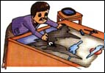
9. A: ________________________________________?
B: No, my father is reading newspapers now.
三、根据上下文，补充句子。
A: _____________________________________?
B: We went to Beijing last winter holiday.
A: Did you see the snow?
B: ________________________. And we saw the maple leaves, too.
A: __________________________?
B: Yes, they’re very beautiful.
A: ?
B: Yes, we took many pictures.
A: ? B: Yes, we had a good time.
四、选词填空。
(last, cleaning, watched, played, washed, visited, cleaned , playing, wash, clean, watch, play)
On the weekend, I can TV. I often_______ the room. Now I’m _______ the room. But weekend, I my grandparents Saturday morning. We ______ TV together. Sunday morning, I _________ clothes and _________ the room. In the afternoon, I _______ football with my friends. I’m going to basketball next weekend.
五、看下面表格所给的内容，根据你自己的需要，选出合适的内容介绍你自己的情况及你上周末的活动。不少于五句话。
Age | Height | Weight | Hobby | Every weekend | Last weekend
12 | 164cm | 42kg | 拉小提琴 | 做作业，看书 | 看电视，踢足球
_________________________________________________________________________________________________________________________________________________________________________________
六年级下册第四单元练习题 Name:______________
一、根据各题的图片，填上合适的单词，使句子完整。
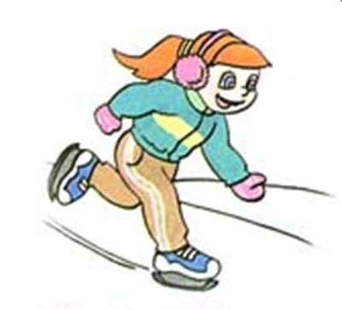
1. A: I went to Harbin and went ________ there last winter.
B: How did you _________? A: I felt __________.
2. A: _______ did they _______ to Beijing last week?
B: They plane. They presents.
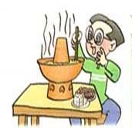
3. A: What did you do on Friday evening?
B: I ________good ________ on Friday evening.
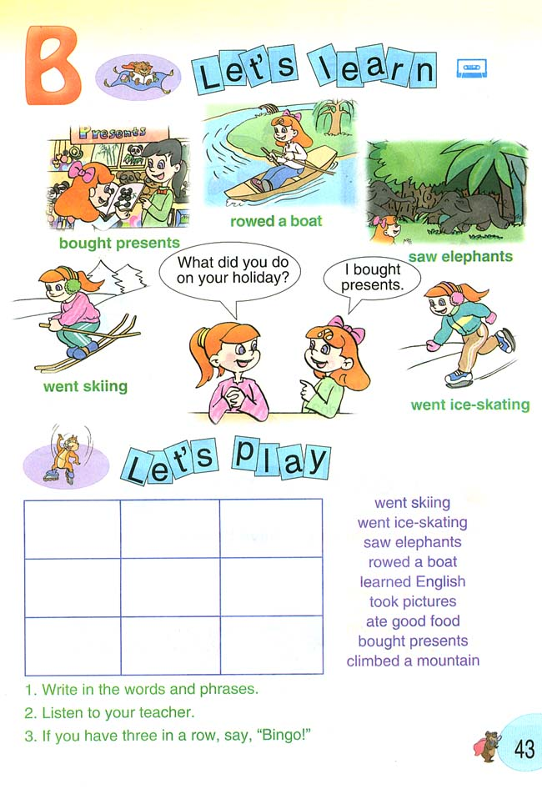
4. A: What did you see yesterday?
B: I ______ many ________ in the zoo yesterday?
二、看答句写问句。
1. A: __________________________? B: He’s reading a book now.
2. A: _________________________? B: Mike played sports yesterday.
3. A: ___________________________________?
B: We went to Hainan by plane last Sunday.
4. A: _____________________________________?
B: Yes, Lucy saw the full moon last night.
5. A: _______________________________________?
B: They’re going to the zoo tomorrow.
6. A: _________________________________?
B: No, I often go to bed at 9:00 in the evening.
7. A: _____________________________________?
B: No, she didn’t play ping-pong this morning.
8. A: ____________________________________?
B: My friend often climbs mountains on the weekend.
9. A: __________________________? B: I feel sick. I have a headache.
10. A: ________________________? B: Tom is 160 cm tall.
三、根据上下文补充句子。
A: Hello, this is Amy. B: Hi! Amy, ______________________?
A: I am listening to the weather report.
B: ? A: It is sunny today.
B: Oh. Let’s go to the museum. There is a kite show.
A: I went there last week. B: ?
A: I went there by car.
B: _______________________________________?
A: I’m going to buy a book about planting trees this evening.
B: ________________________________________?
A: Yes, I like planting trees very much.
四、选词填空：( took, climbed, food, saw, older, sang, happy, old, mountains, had, take, have )
Yesterday I________a mountain with my cousin Tom. Tom is 13 years ________. He is one year ________than I. We took some _________and drinks with us. And Tom took his camera, too. On the mountain, we took a lot of pictures of the beautiful scenery. When we got to the top of the _________, it was 1:25 p.m. We _______and danced there. We got tired. But we felt very ________. Because we________ some squirrels and ________many pictures. We ________a good time.
五、根据以下七个信息，选择五个来介绍你的生活。
Name | Amy
Age | 12
Birthday | 四月22日
Ability(能力) | 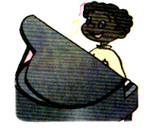  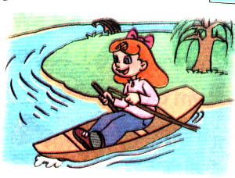
On the weekend | 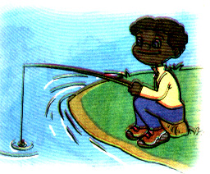
Last weekend | 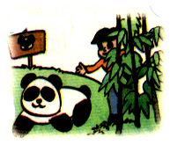
This weekend | 



