PEP三年级下册英语期中达标测试题

题号 | 一 | 二 | 三 | 四 | 五 | 六 | 七 | 八 | 九 | 十 | 总分
得分
听力部分（70分）
一、听音，标序号。（8分）





( ) ( ) ( ) ( )
二 、听录音，选择你所听到的单词。（10分）
( ) 1. A.student B.teacher C. pupil
( ) 2. A.fat B.thin C. short
( ) 3. A.big B.pig C. milk
( ) 4. A.USA B.UK C. China
( ) 5. A.brother B.grandpa C. father
三、听录音，选择与所听内容相对应的图片。(10分)
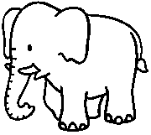
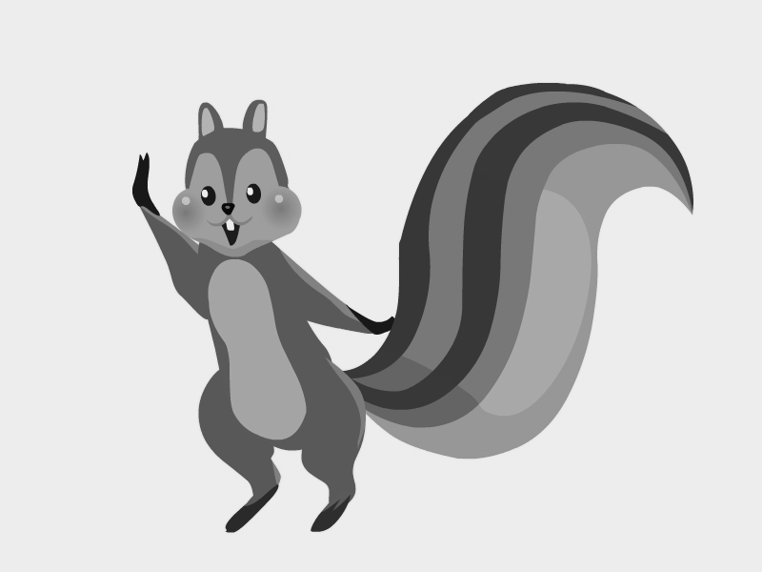
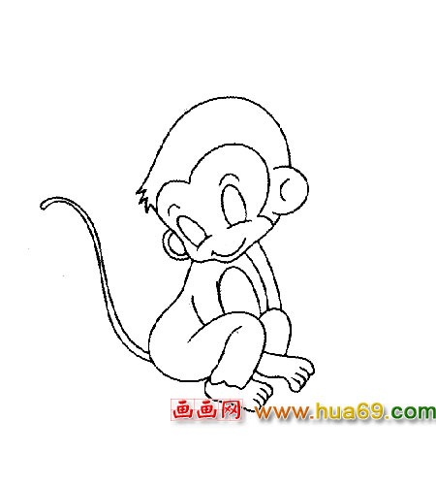
1.
2.
3.

( ) ( ) ( )

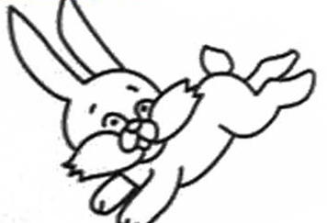
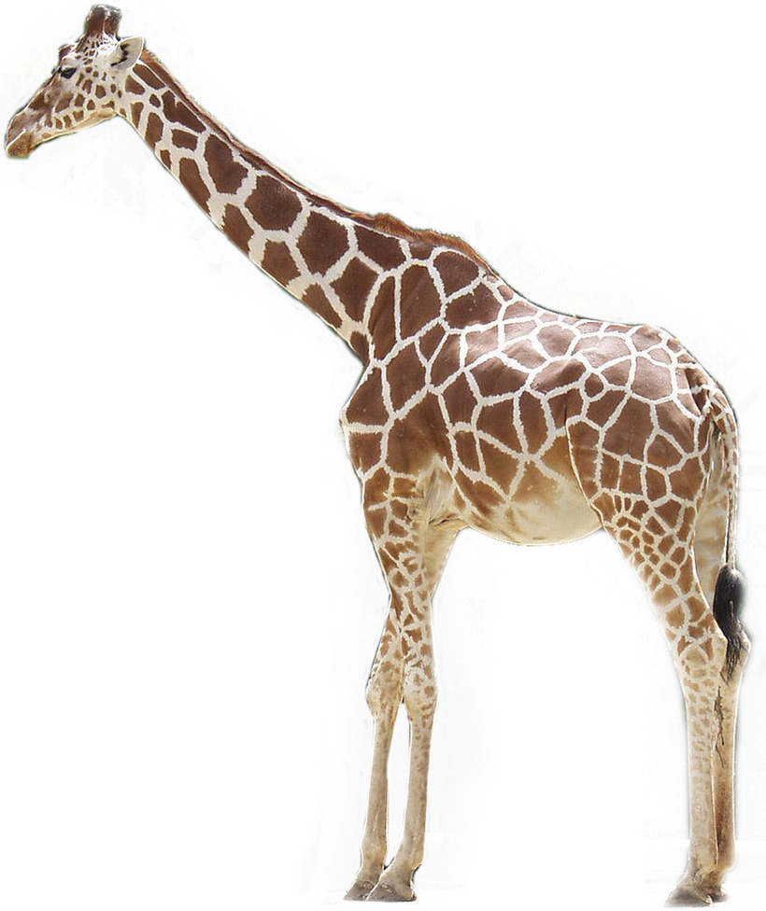

4、 5.

( ) ( )

A. a long nose B.a long tail C.a long neck(脖子）
D. a big tail E.long ears
四、听录音,根据所听到的内容判断下列句子的正（T）误（F) (10分)
( ) 1.Welcome back to school.
( ) 2.The man is my grandfather .
( ) 3.Who’s that boy ?
( ) 4.I have a new friend today .
( ) 5.He has big ears .
五、听录音，选出你所听到的句子。(12分）
( ) 1.A. I’m from Canada . B. I’m from the USA.
( ) 2.A. She’s a student . B .He’s a teacher.
( ) 3.A. Who’s that man ? B .Who’s that woman ?
( ) 4.A. It has small eyes. B .It has a long nose .
( ) 5.A. It’s short and fat . B .It’s fat .
( ) 6.A.This is my friend,John. B.He’s my friend,John.
六、听录音，给所听到的问题选择正确答案。（8分）
( ) 1. A. Nice to meet you. B. I’m from the UK.
( ) 2. A. Yes, she is. B. I’ m Amy .
( ) 3.A. He’s my brother. B. She’s my sister.
( ) 4.A .Yes, he is. B. Yes, she is.
七、听录音标序号，用数字标出听到句子的顺序号（12分）

( ) 1.He’s my father .
( ) 2.Hi ,Dad .
( ) 3.Who’s that man ?
( ) 4.Nice to meet you .
( ) 5.This is my friend ,Amy .
( ) 6.Nice to meet you ,too .

笔试部分（30分）
八、将下列单词按照示例归类，并将序号填在( )内。(10分)

① long ② mother ③ UK ④ sister ⑤ thin
⑥ Canada ⑦short ⑧ dad ⑨ fat ⑩ USA
1. China
2. brother
3. big
九、单项选择。（10分）
1.Wu Qiaoqiao is China.
A. at B. from
2.Is he your father ?
A.No ,he isn’t . B.Yes, she is .
3.We a new friend today .
A.have B. has
4.This is my sister . is a teacher .
A.She B.He
5.It has a long body and short legs .
A.a B.不填
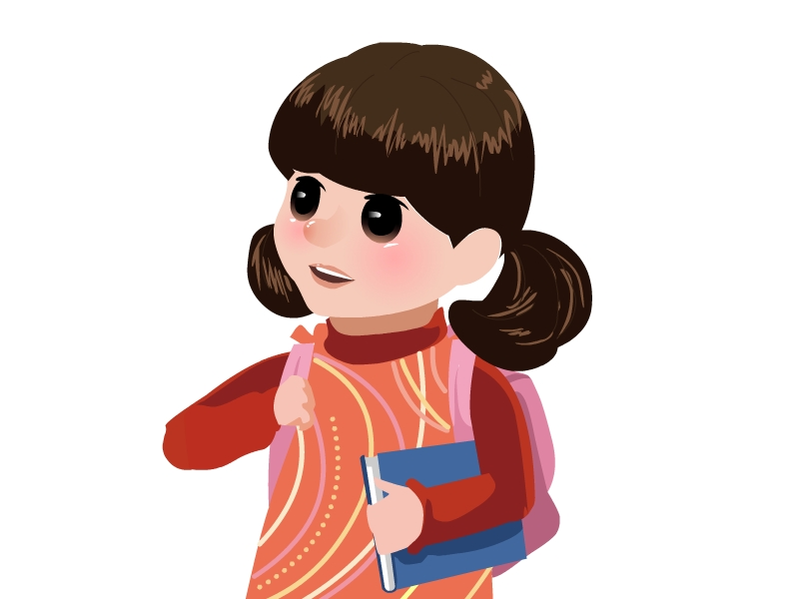
十、看一看，连一连（10分）
- I’m from China . A.

2.She’s a student . B.

3.This is my family. C.

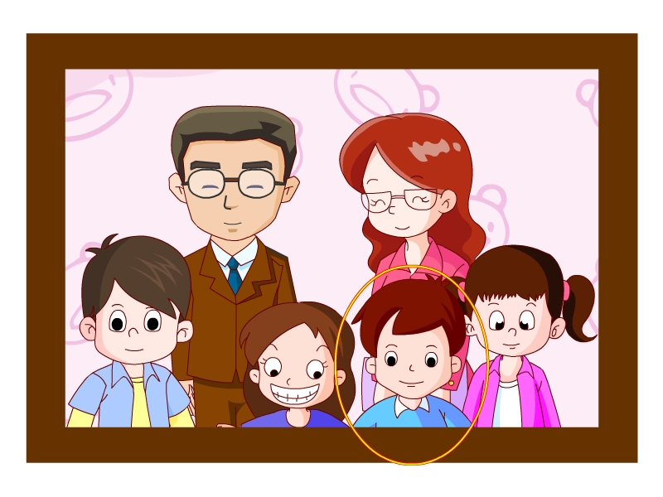
4.He’s my father . D.


- Look at the bear.It’s fat and short . E。
三年级听力材料
一、听音，标序号。（8分）
1. Hi,I’m Mike.I’m from Canada
2.My name is Chen Jie .I’m from China .
3.Amy is from the UK .
4.This is Sarah .She is from the USA.
二 、听录音，选择你所听到的单词。（10分）
1. pupil 2.thin 3.milk 4.China 5.grandpa
三、听录音，选择与所听内容相对应的图片。(10分)
1.The monkey has a long tail .
2.The elephant has a long nose.
3.Zip has a big tail .
4.The rabbit have long ears .
5.The giraffe has a long neck .
四、听录音,根据所听到的内容判断下列句子的正（T）误（F) (10分)
1.Welcome back to school.
2.The man is my father .
3.Who’s that man ?
4.I have two new friends today .
5.He has big ears .
五、听录音，选出你所听到的句子。(12分）
1. I’m from the USA.
2. He’s a teacher.
3.Who’s that woman ?
4. It has small eyes.
5. It’s short and fat .
6.This is my friend John.
六、听录音，给所听到的问题选择正确答案。（8分）
1. Where are you from ?
2. Is she your grandma ?
3. Who’s the boy ?
4.Is he your father ?
七、听录音标序号，用数字标出听到句子的顺序号（12分）

( 2 ) 1.He’s my father .
( 3 ) 2.Hi ,Dad .
( 1 ) 3.Who’s that man ?
( 5 ) 4.Nice to meet you .
( 4 ) 5.This is my friend ,Amy .
( 6 ) 6.Nice to meet you ,too .

