PEP人教版小学三年级英语上册全套单元测试题

三年级上册Unit 1单元测试卷
Class______ Name_________ Mark________
笔试部分（20分）
七 请将正确的图与英文单词连线。（5 分）

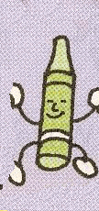
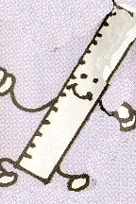
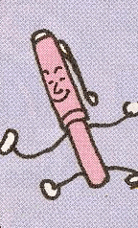
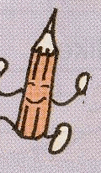

crayon pen pencil ruler eraser

八 请把正确的图与英文句子连线。（5 分）

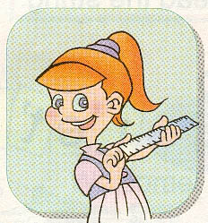
Goodbye!

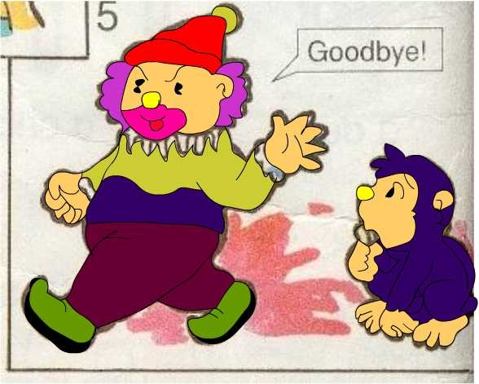

Hello, my name is Book.

Hello, I am Eraser.

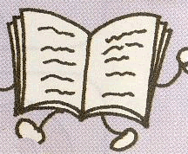
Show me your pen.

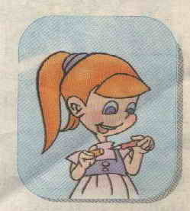
Show me your ruler.

Unit2单元测试
班级_______________ 姓名______________ 分数_____________
笔试部分
- 根据图片, 填上所缺的字母. （10分）
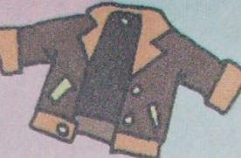
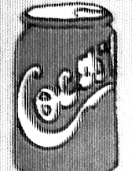
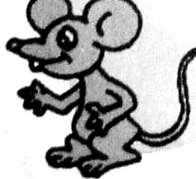
- __acket 2. __oke 3. __ouse

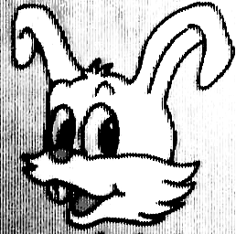
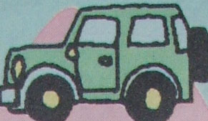
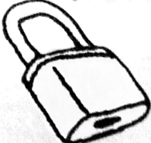
4. , __abbit 5. __eep 6. __ock
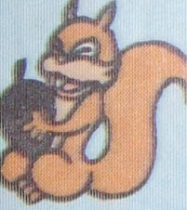
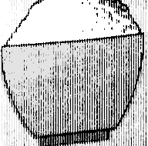
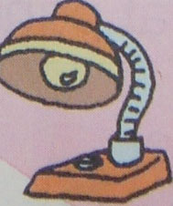
7. s__uirrel 8. __ice 9. __amp

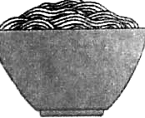
10. __oodles

- 将下列单词填入空格, 把对话补充完整. （10分）
have green eleven wall classroom
big nice too near like

Sarah: Mike, we have a new __________.
Mike: Really? Let’s go and _______ a look.
Sarah: OK.
Mike: Wow! It’s so ______!
Sarah: We have ______ lights.
Mike: Look! The ______ is white. The floor is _______.
Sarah: Look at the picture.
Mike: It’s very _______. Where is my seat?
Sarah: It’s ______ the door.
Mike: I ______ our new classroom.
Sarah: Me ______.
八. 选句补充对话,将正确的句子的编号填在横线上. （10分）
- How many picture books do you have?
- What color is it?
- How nice!
- What’s in it?
- May I have a look?
Amy: Hi, Chen Jie. I have a new schoolbag.
Chen Jie: Really? ________________________
Amy: It’s black and white. Look! It’ s so heavy.
Chen Jie: _____________________
Amy: Some English books, some story-books, and many picture books.
Chen Jie: __________________________
Amy: Let me count. 1, 2, 3, 4…15. I have 15 picture books.
Chen Jie: _______________________________
Amy: Sure. Here you are.
Chen Jie: Wow! A fat panda! ___________

Exercise For Unit 3
Class:________ Name:_________ Mark:_______
一、看一看，画出相应的图画。
1．a green ruler 2. a red mouth 3. a yellow book

4. a blue nose 5. a purple foot

（Unit 4）
Class Name No. Marks
笔试部分（30分）
八.给下列的句子找合适的答语,连线.(10分)
1. Where is your ear? Good morning.
2. Good morning. Here it is.
3. How are you? I’m fine, thanks.
4. Let’s go to school. My name’s John.
5. What’s your name? Ok!

九．从方框中选出最佳的句子完成下列对话。（10分）
A. May I have a look?
B. Thanks.
C. Oh. It’s nice.
D. I have a Teddy Bear.

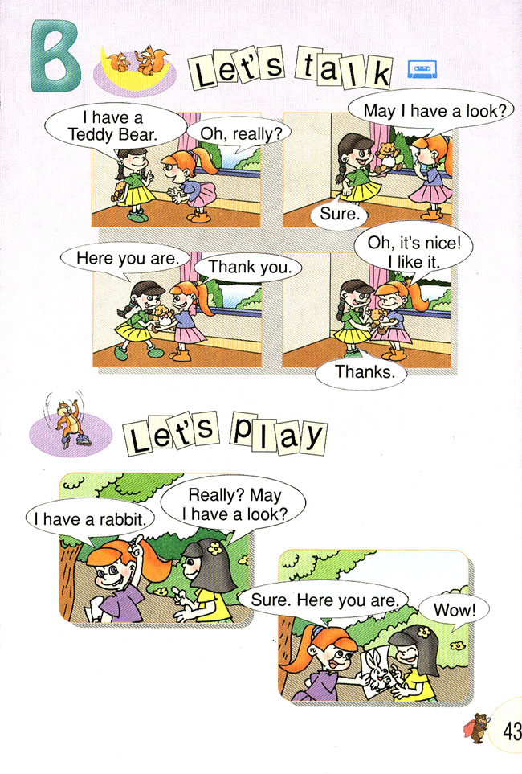

九．根据所给出的单词，给下面的图片涂上相应的颜色。（20分）

十．给下列图片选择合适的单词,把序号填入括号里.(10分)
A. mouse B.mouth C.pink D. ear E.eye
F.monkey G.squirrel H.rabbit I. sharpener J.bird
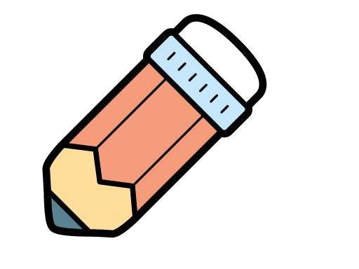
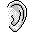
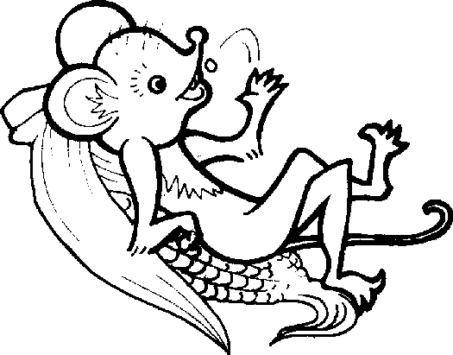
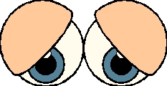

粉红

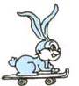
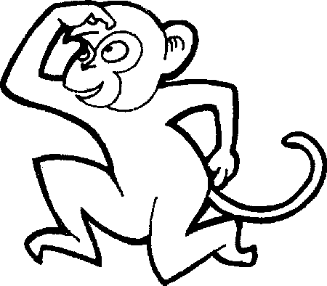
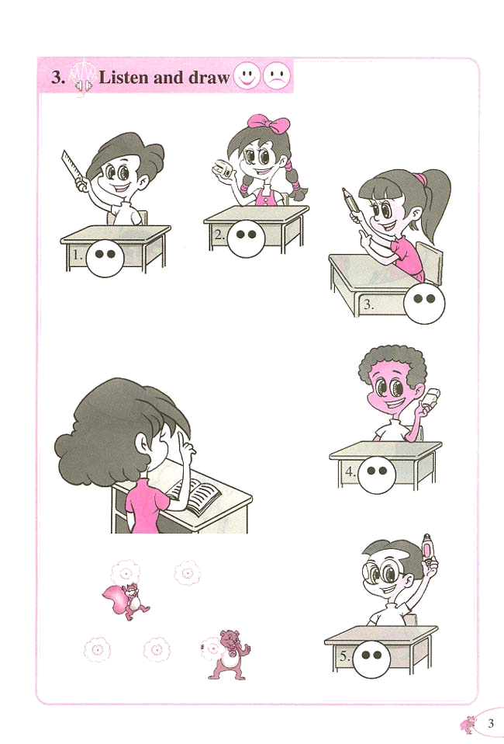
( ) ( ) ( ) ( ) ( )
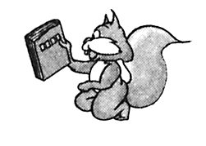
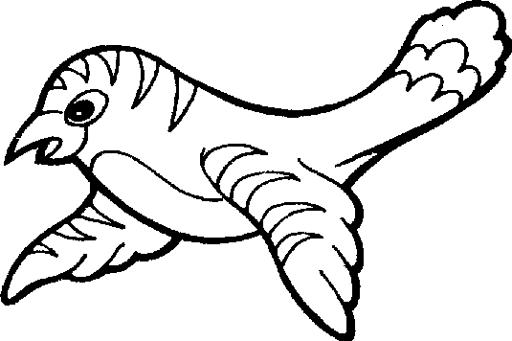

( ) ( ) ( ) ( ) ( )

Exercise For Unit 5
Class:___________ Name:______________ Mark:_____________
一．认一认，选一选。并在正确单词的括号里打“√”
like ( )
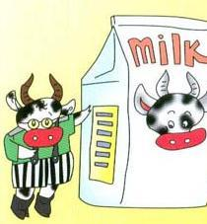
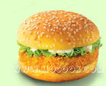
hamburger ( )
1．
2.
milk ( )
hot dog ( )
chicken ( )
Coke ( )
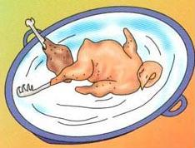
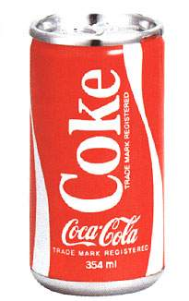
4.
3.

cake ( )
cake ( )

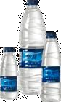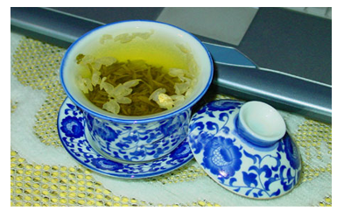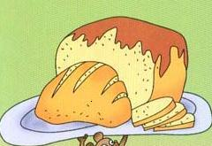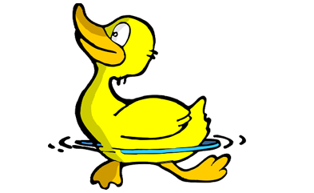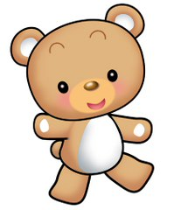
5.
ten ( )
tea ( )
6.
8.
7.
brown ( )
bread ( )
white ( )
water ( )
cake ( )
cat ( )
9.
dog ( )
duck ( )
10.
bird ( )
bear ( )
二．找出同类单词，并将同类单词圈起来。
1 coffee Coke juice chicken
2 hot dog bread dog hamburger
3 cake water squired French fries
4 ear arm eye tea
5 bear bird milk pig

三． 将下面各个句子，根据你的判断，填到对话的横线上，
只填句子前的字母编号。
A Sure. Here you are. B Good afternoon!
C You’re welcome. D No, thanks!
E Here you are.

A : Good afternoon, mom!
B : _____________________
A : Can I have some chicken?
B : _____________________
A : Thank you.
B : ____________________ Have some Coke!
A : ____________________ I like juice.
B : Ok! __________________
A : Thank you.

（Unit 6）
Class Name No. Marks

八．找出单词中不同类的词语，把其序号填在左边的括号里。(10分)
（ ）1、A、body B、book C、crayon
（ ）2、A、head B、bread C、arm
（ ）3、A、black B、bird C、brown
（ ）4 A、mouth B、mouse C、monkey
（ ）5、A、juice B、water C、bear
（ ）6、A、seven B、eight C、coffee
（ ）7、A、ballon B、some C、kite
（ ）8、A、door B、doll C、ball
（ ）9、A、boat B、milk C、plane
（ ）10、A、plane B、purple C、pink

九．从方框里选出最佳选项。(10分)
A. Thank you.
B. 5.
C. Very well, thanks.
D. No, thanks.
E. I’m 8.

( )1. How are you?
_________________
( )2.How old are you?
__________
( )3. How many balloons?
____________.
( )4. Happy birthday.
_____________
( )5.Have some juice.
____________.
十．选择合适的答语，用线连起来。
1.Happy teacher’s day. Nice to meet you too.
2.Nice to meet you. Thank you.
3.Can I have some cakes? Sure. Here you are.
4.Let’s go to school. Good afternoon.
5.Good afternoon. Ok.
同学们，做完了要认真仔细检查哦，这样你会考得更棒的。

